Experiment No : 1

Bracket 3D Model Preparation

(Paste Diagram on left side page)

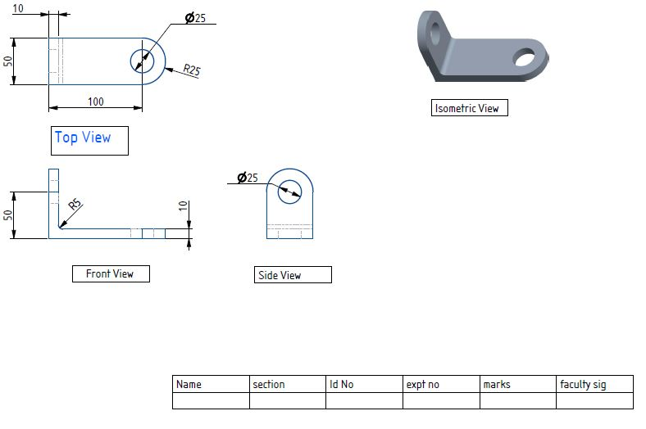

**Write-Up on right side pages only**

**Aim / Objective**: Prepare 3D Model of Bracket Chanel

**Software Used / Tools Ruqired:** creo parametric 5.0.4.0 /3D printer

**Learning Objectives**:  

* Create Simple Extruded Solid Models.
* Understand the Basic Parametric
* Modelling Process.
* Create 2-D Sketches.
* Understand the "Shape before Size" approach.
* Use the Dynamic Viewing commands.
* Create and Modify Parametric Dimensions

**Commands Used**:

Sketch View, Rectangle, Circle, Extrude, Round etc.

**Step by step procedure:**

1. Select part model and solid modelling and give the name of the part model
2. Select Top plane and go to sketch module
3. Select perpendicular view of the plane select from dynamic tool bar show in the picture
4. Select rectangle tool to draw from sketch tool bar
5. Draw a rectangle of any dimensions
6. Now to assign dimensions select dimension tool from sketch tool bar and assign given dimensions to the rectangle
7. Select circle tools from sketch tool bar. Draw a circle from midpoint of 50cm edge to the next corner of dia 50cm.
8. Select delete segment tool from sketch toolbar and trim unnecessary edges and curves as show in picture by dragging towards the semicircle and one edge of rectangle.
9. Next, draw another circle of 25cm dia from center of the 50cm dia circle as shown
10. Now exit the sketch module and click extrude tool from model toolbar
11. Add a thickness of 10mm and click ok in extrude toolbar
12. Now select right plane and select sketch module again
13. Again click perpendicular view icon from dynamic toolbar in model window as shown in below picture
14. Now follow the same procedure used to model the base and complete the sketch
15. Once you done with sketch module go to extrude module and give thickness of 10mm and click ok.
16. Now select the corner as shown in below picture and select round tool in model toolbar to give fillet
17. Add fillet radius of 5mm and click ok.
18. Now go to file option, click save as and select target folder to save.
19. Save it in prescribed format and click ok to complete the exercise.

**Result:** Hence 3D Model Of Bracket Chanel Prepared.